**Name: Session:**

**Programming II**

**Lab Exercise 5/20/2022**

**First ASP.NET Page**

In this exercise, you will create your first ASP.NET application. We will be running your Web Application from the local host web server. To serve your page up, you will need to configure your web server and place your page in c:\inetpub\wwwroot. We will not be doing this today.

1. Start Visual Studio and create a new C# project but this time choose ASP.NET Web Application.
2. You will notice that when you create this it will run it from http:localhost/WebApplication1
3. Let’s start by placing a Textbox, Label, and Button on your Webform
4. Add code to take what is in your textbox and place it in the label when you click on the button.
5. Now test your application by hitting the Start Without Debugging button. You will not be able to run with debugging since you do not have administrative privileges.

Now that you have made a simple ASP.NET application, let’s make something a bit more useful. Create a web application that calculates the monthly payment given the initial amount of the loan, the interest rate, and the duration of the loan.

**More ASP Applications**

1. Create a Web Calendar application that looks something like this:

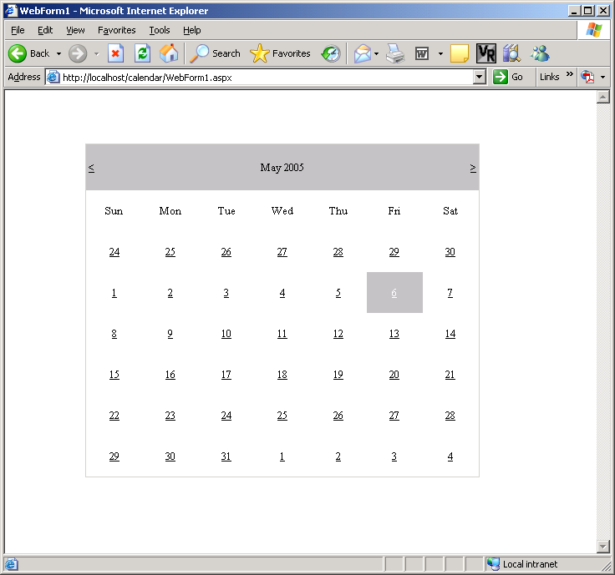

Your application should run from a Web page.

1. Build a Loan Application project that looks something like this:

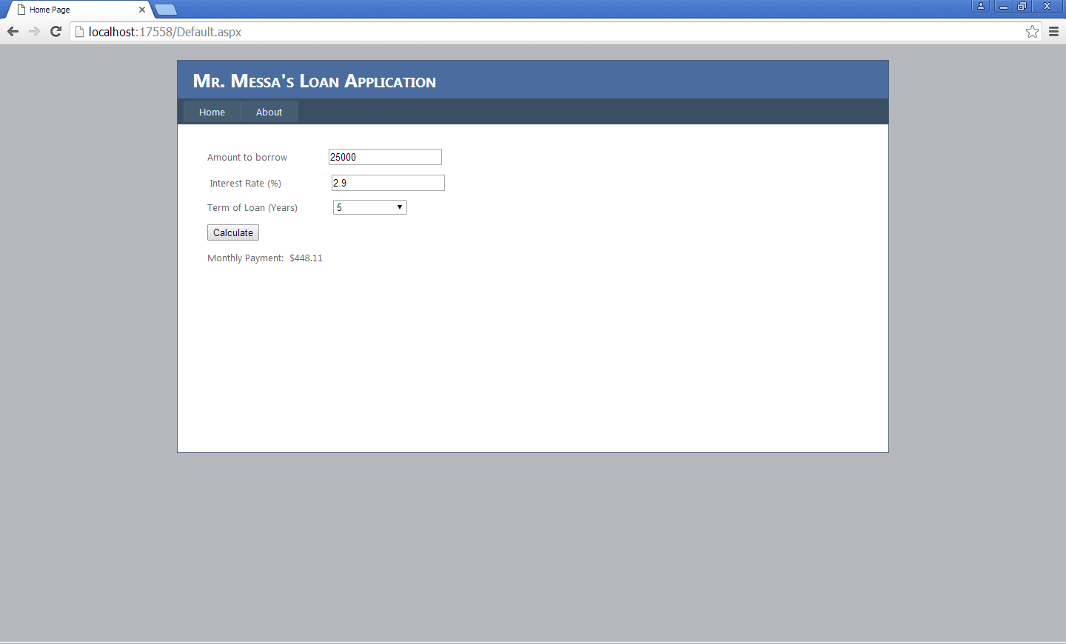

Your application should run on a web page.